Rediscovering Japanese Traditional

Performing Arts
Traditional and contemporary Koto/Shakuhachi music
in collaboration with Piano and Dance

Presented by Masumi Timson (Koto)
With Kazuhiko Shindo (Shakuhachi), Nozimi Tokita (piano),
and Takamori Fujima (Dance)
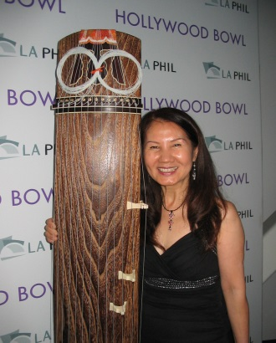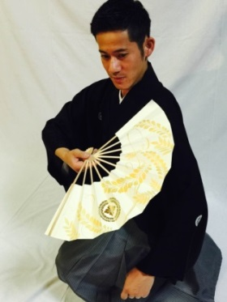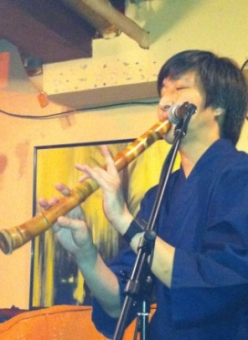

The history of Koto and Shakuhachi – Japanese traditional and ancient musical instruments - dates back over 1,400 years, and has seen many changes during this time. Koto Master Masumi Timson’s presentation will include a power point presentation on a) the historical background of koto/shakuhachi music, b) characteristics of the instruments, c) the influence of Japanese traditional culture on its traditional music, d) the influence of Western music, e) the history and forms of Japanese traditional dance. The lecture will be followed by a performance of the musical chronology of traditional Japanese music, the drama of tango, and the improvisational free flowing nature of jazz, accompanied by the piano and contemporary and traditional Japanese dance. You can see and hear how Japanese traditional musical instruments blend the music of Eastern and Western cultures in an amazing musical collaboration.

Masumi Timson’s profile: www.masumi-koto.com
Masumi holds a Master’s Degree (師範) in Koto from Seiha Conservatory of Japanese traditional music. She participated in the recording of the world-renowned band Pink Martini's several albums, including 2011 Japan Record Award Winner and iTunes No. 1 Jazz Chart Hit “1969,” with Japanese legendary singer Saori Yuki. Masumi has performed with the band at venues including Carnegie Hall (NY), the Hollywood Bowl (LA), Grand Rex Theatre (Paris), Tokyo Kokusai Forum, and Billboard Live Tokyo etc. She has also released her own CDs, Picture Dreams (Koto/Violin Duo), a collaboration album with Fumino Ando (Oregon Symphony), and Pacific Bridge, with Richard Crandell featuring the koto and mbira, a traditional African instrument.

